Ceramic Hip Resurfacing

A bone-preserving alternative to total hip replacement for selected patients

Hip resurfacing is a surgical procedure used to treat hip arthritis while preserving more of your natural bone compared to a total hip replacement. Rather than removing the entire head of the femur (thigh bone), the joint is reshaped and capped with a smooth ceramic surface, allowing the hip to continue functioning as a ball-and-socket joint.

This approach may be considered for selected patients, particularly those who are younger, active, and wish to maintain a higher level of activity following surgery. By preserving more of the natural bone, hip resurfacing may offer an alternative option for managing hip pain and joint damage in appropriate cases.

Dr Paul Harvie offers ceramic hip resurfacing as part of his approach to treating hip arthritis. During your consultation, he will assess your hip joint, review imaging, and discuss whether this procedure may be suitable based on your anatomy, condition, and lifestyle goals.

What is Ceramic Hip Resurfacing?
Ceramic Hip Resurfacing vs Total Hip Replacement
Why Ceramic Instead of Metal-on-Metal?
Who May Be Suitable for Ceramic Hip Resurfacing?
When is Hip Resurfacing Not Recommended?
Benefits of Ceramic Hip Resurfacing
Risks and Considerations of Hip Resurfacing Surgery
How Ceramic Hip Resurfacing Surgery Works
Hip Resurfacing Implants and Ceramic Components
Recovery, Physiotherapy and Rehabilitation After Hip Resurfacing Surgery
Returning to Sport and Activity After Hip Resurfacing
Hip Resurfacing FAQ’s

What is Ceramic Hip Resurfacing?
Ceramic hip resurfacing is a type of hip resurfacing procedure that uses advanced ceramic bearing surfaces rather than traditional metal components. In this technique, the surface of the femoral head is preserved and capped with a smooth ceramic component, while the socket is fitted with a corresponding ceramic-lined surface. These materials are designed to allow the joint to move with low friction and minimal wear.

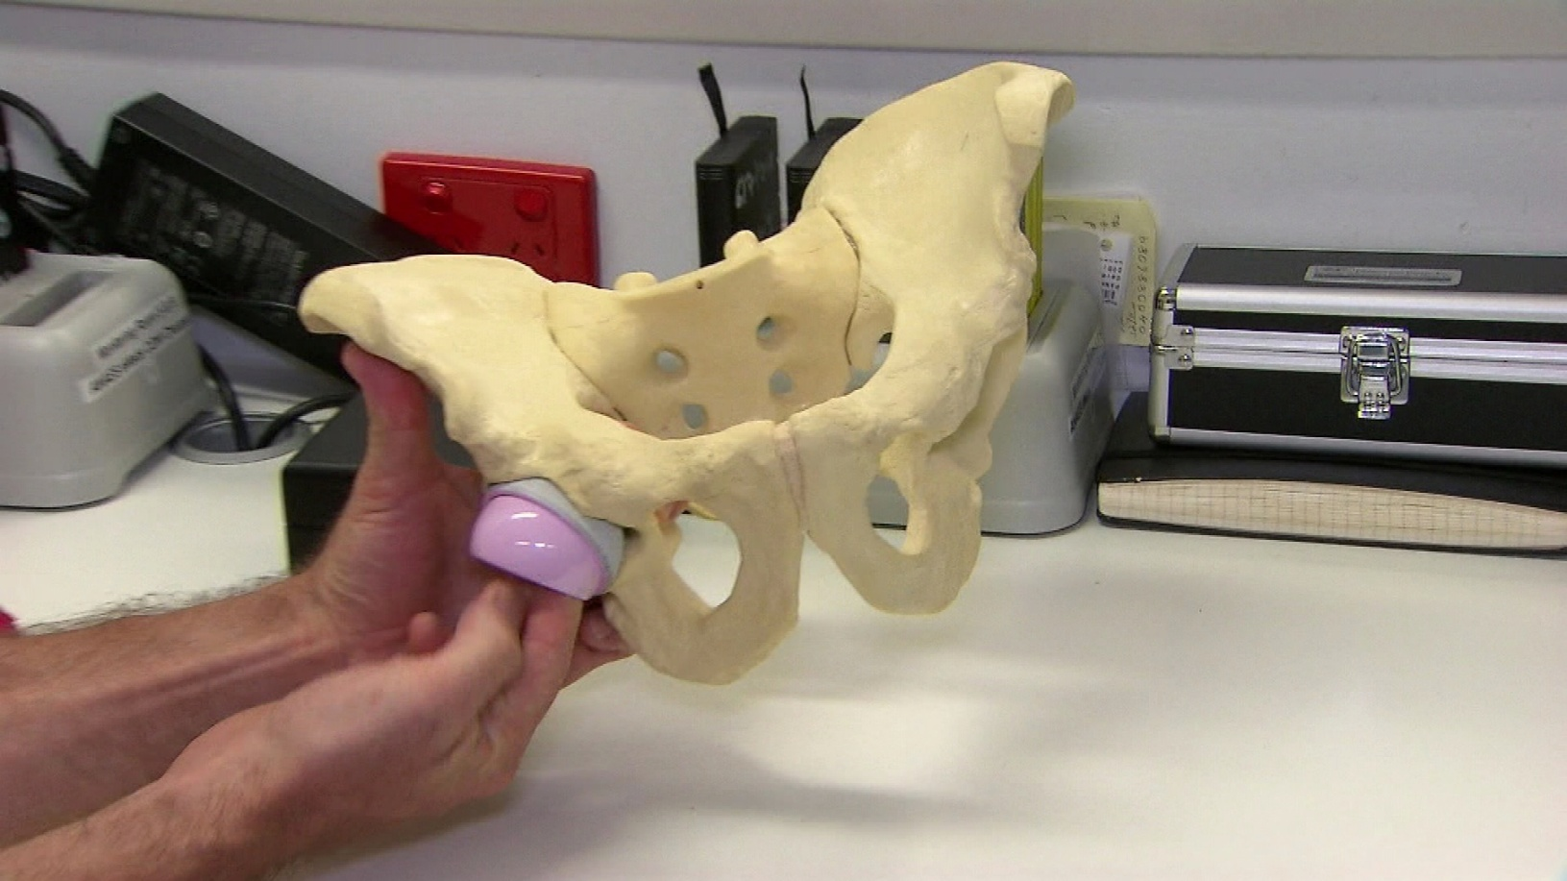
Ceramic hip resurfacing has been developed as an alternative to metal-on-metal hip resurfacing, with the aim of avoiding issues related to metal wear particles while maintaining the bone-preserving advantages of resurfacing.

Ceramic Hip Resurfacing vs Total Hip Replacement
Ceramic hip resurfacing and total hip replacement are both surgical options used to treat hip arthritis and joint damage. While both procedures aim to relieve pain and improve movement, they differ in how the hip joint is treated and reconstructed.

Key Differences
Feature | Hip Resurfacing | Total Hip Replacement
Bone preservation | Preserves more of the natural bone by retaining the femoral head and covering it with a prosthetic surface | Involves removing the femoral head and replacing it with a stem and ball component
Joint mechanics | Maintains more of the natural anatomy of the hip joint | Recreates the joint using artificial components designed to restore movement and stability
Implant design | Uses a cap-and-socket design that fits over the existing bone | Uses a stem inserted into the femur with a ball that articulates within a socket
Future considerations | Preserving bone may be beneficial if further surgery is required in the future | A well-established procedure with predictable outcomes across a wide range of patients
Which option may be suitable? | May be considered in younger, active patients with good bone quality | Typically recommended for a broader range of patients, particularly where bone quality or joint damage makes resurfacing less suitable

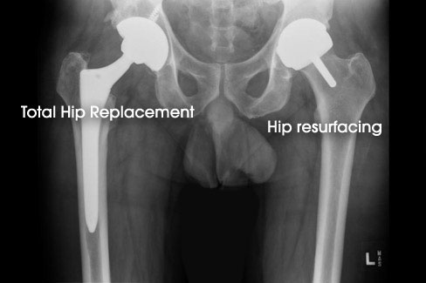

Why Ceramic Instead of Metal-on-Metal?
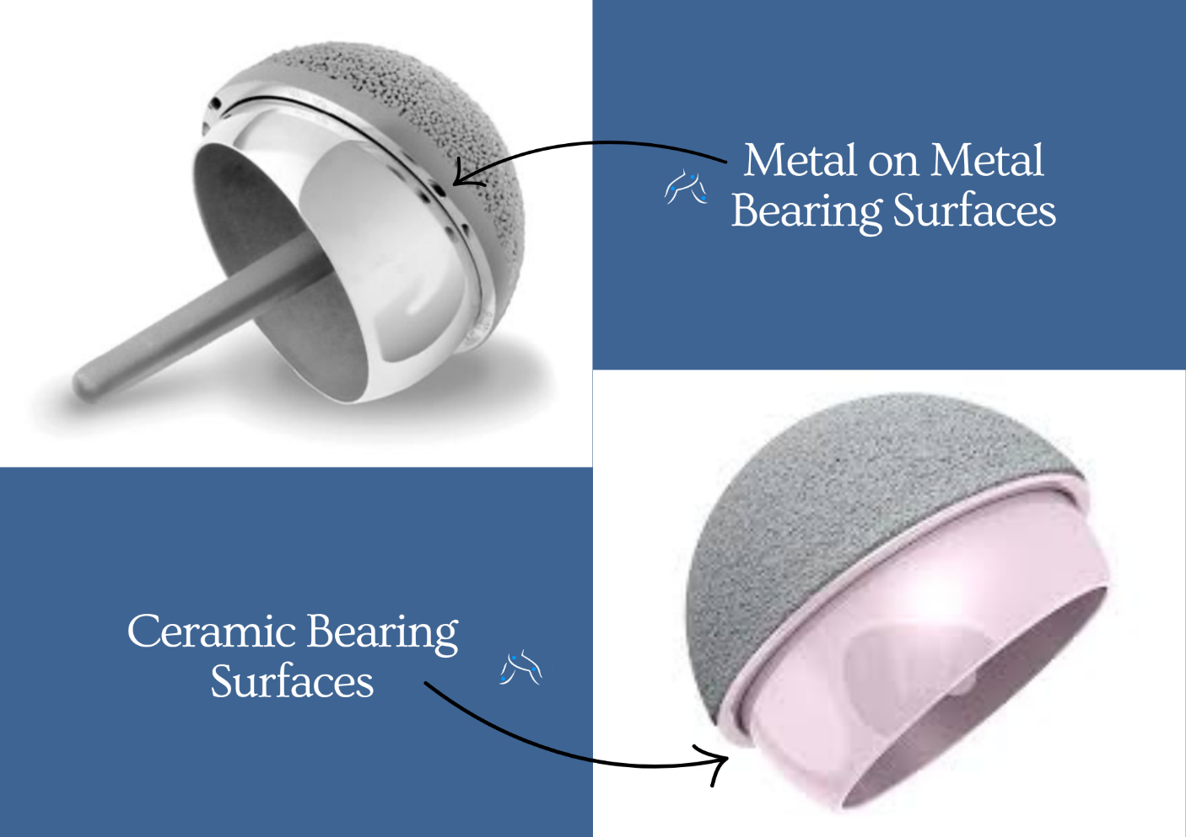
Traditional hip resurfacing procedures have commonly used metal-on-metal bearing surfaces, where both sides of the joint are made from metal. While this approach has been effective in restoring joint function, concerns have been raised over time regarding metal wear particles and how they may affect surrounding tissues. Ceramic hip resurfacing has been developed as an alternative, using advanced ceramic materials designed to address some of these concerns while maintaining the bone-preserving benefits of resurfacing.

Key Differences Between Ceramic and Metal Bearings
Wear characteristics
Ceramic surfaces are engineered to be extremely smooth and hard, which may help reduce wear over time compared to traditional metal-on-metal bearings.
Material properties
Ceramic does not produce metal ions. This may be an important consideration for patients where minimising exposure to metal particles is preferred.
Biocompatibility
Ceramic materials are widely used in orthopaedic surgery due to their biocompatibility and resistance to corrosion.

Why This Matters
The choice of bearing surface is an important part of surgical planning. Using ceramic components may help address some of the limitations associated with earlier metal-on-metal designs, while still allowing patients to benefit from a bone-preserving resurfacing procedure. The most appropriate implant and technique will depend on individual factors such as anatomy, bone quality, and the underlying condition affecting the hip joint.

Who May Be Suitable for Ceramic Hip Resurfacing?
Ceramic hip resurfacing may be considered for selected patients with hip arthritis or joint damage, particularly where preserving bone and maintaining a high level of activity are important considerations. This procedure is not suitable for everyone, and careful assessment is required to determine whether hip resurfacing is an appropriate option.

Patients who may be considered suitable for ceramic hip resurfacing often include those who:
• Are younger and more active, with higher functional demands
• Have good bone quality, particularly in the femoral head and neck
• Have hip arthritis that is primarily affecting the joint surfaces
• Have a larger bone structure, which may allow for more reliable implant positioning
• Wish to maintain an active lifestyle following surgery

Factors That May Influence Suitability
Certain factors may make hip resurfacing less suitable, including:
• Poor bone quality or osteoporosis
• Significant deformity or damage to the femoral head
• Certain types of inflammatory arthritis
• Previous surgery affecting the structure of the hip
• Smaller bone anatomy in some patients

Because hip resurfacing relies on preserving and supporting the existing bone, bone quality and anatomy are important considerations when determining suitability. A detailed assessment, including imaging, is used to evaluate whether ceramic hip resurfacing may be appropriate based on your individual condition and treatment goals.

When is Hip Resurfacing Not Recommended?
Hip resurfacing is not suitable for every patient. Because the procedure relies on preserving and supporting the existing bone, certain factors may make it less appropriate or increase the risk of complications.

Hip resurfacing may not be recommended in situations where:
• Bone quality is reduced, such as in osteoporosis
• There is significant damage or deformity of the femoral head
• The hip joint has been affected by advanced arthritis with bone loss
• There is a history of previous surgery that has altered the structure of the hip
• Certain types of inflammatory arthritis are present
• The bone structure is smaller or less able to support the resurfacing implant
• There is an active infection in the body or around the hip joint

General health factors may also influence whether hip resurfacing is appropriate, particularly if there are medical conditions that increase surgical risk. In these situations, total hip replacement may be a more suitable option, as it does not rely on preserving the femoral head and can be used across a wider range of patients and bone conditions.

Careful assessment of bone quality, joint structure, and overall health is an important part of determining the most appropriate surgical approach.

Benefits of Ceramic Hip Resurfacing
Ceramic hip resurfacing offers a number of potential advantages for selected patients, particularly where preserving bone and maintaining an active lifestyle are important considerations. Because this procedure differs from a total hip replacement, the benefits relate to both the bone-preserving surgical approach and the use of ceramic bearing surfaces.


Potential benefits of ceramic hip resurfacing may include:
• Preservation of natural bone
The femoral head is retained rather than removed, which may be beneficial for maintaining bone stock.
• More natural hip mechanics
Maintaining the native bone structure may help preserve more natural joint movement and biomechanics.
• Reduced risk of metal-related complications
Ceramic components do not produce metal ions, which may address concerns associated with traditional metal-on-metal resurfacing.
• Low wear characteristics
Ceramic materials are designed to be smooth and durable, which may help reduce wear over time.
• Potential suitability for active patients
In selected cases, hip resurfacing may be considered for patients wishing to return to higher levels of physical activity following recovery.
• Future surgical options
Preserving bone may provide additional options if further surgery is required later in life.

The potential benefits of ceramic hip resurfacing vary between individuals and depend on factors such as bone quality, anatomy, and activity level.

Risks and Considerations of Hip Resurfacing Surgery
Hip resurfacing is a well-established surgical procedure, however, as with any operation, there are potential risks and considerations that patients should be aware of.
While many procedures are completed successfully, outcomes can vary depending on factors such as bone quality, anatomy, activity level, and overall health. Because hip resurfacing preserves the femoral head, certain risks are specific to this technique and differ from total hip replacement.
Potential risks and considerations may include:
Femoral neck fracture
Because the femoral head and neck are preserved, there is a small risk of fracture in this area following surgery, particularly in the early stages of recovery.
Implant loosening or wear
Over time, resurfacing components may wear or loosen, which may require further treatment or revision surgery.
Persistent pain or groin discomfort
Some patients may experience ongoing discomfort following surgery, including irritation of surrounding soft tissues.
Iliopsoas tendinitis
Irritation of the iliopsoas tendon at the front of the hip can occur and may cause groin pain in some cases.
Infection
Infection can occur around the surgical site or the implant. Preventative measures are used to reduce this risk.
Blood clots (Deep Vein Thrombosis)
Blood clots can occasionally develop in the legs following surgery. Early mobilisation and medications are used to reduce this risk.
Nerve or blood vessel injury
Although uncommon, nearby nerves or blood vessels may be affected during surgery.

Considerations Specific to Hip Resurfacing
Hip resurfacing relies on preserving the existing bone, which means that bone quality and structure are important factors in both the success and longevity of the procedure. For this reason, careful patient selection is important, and in some cases, total hip replacement may be a more appropriate option depending on the condition of the joint.

Understanding these risks and considerations is an important part of making an informed decision about treatment.

How Ceramic Hip Resurfacing Surgery Works
Ceramic hip resurfacing is performed using a carefully planned surgical technique designed to treat the damaged joint surfaces while preserving as much of the natural bone as possible. Once the anaesthetic has taken effect, the hip joint is accessed using an appropriate surgical approach. The surrounding soft tissues are carefully managed to allow controlled and accurate exposure of the joint.
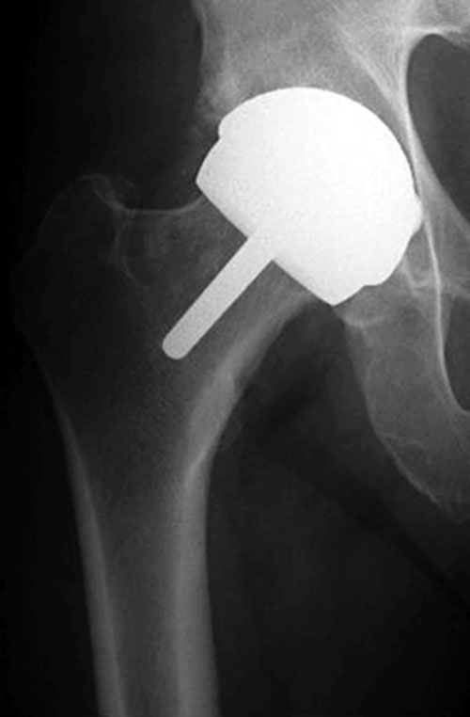
Preparing the femoral head
The surface of the femoral head (the ball of the hip joint) is carefully reshaped to remove damaged cartilage and create a smooth, stable surface. This allows the resurfacing component to fit accurately over the existing bone.
Placing the femoral component
A ceramic resurfacing component is then placed over the prepared femoral head. This acts as a new smooth surface for the joint while preserving the underlying bone.
Preparing the hip socket
The acetabulum (hip socket) is shaped to remove damaged cartilage and prepare it for the socket component. Careful preparation helps ensure the implant sits securely and functions smoothly.
Inserting the socket component
A corresponding ceramic-lined socket component is placed into the pelvis. This allows the joint to move with low friction and supports smooth, stable movement.
Final assessment and closure
Once the components are in place, the hip joint is assessed for stability, movement, and alignment. The surrounding tissues are then returned to their natural position, and the incision is closed.

The procedure typically takes approximately one to two hours, although this can vary depending on individual factors. Patients are monitored closely following surgery as they begin the early stages of recovery. This approach focuses on preserving the natural bone structure of the hip while addressing the damaged joint surfaces, allowing the joint to function smoothly following surgery.

Hip Resurfacing Implants and Ceramic Components
Ceramic hip resurfacing uses specially designed components to recreate the smooth movement of the hip joint while preserving the natural bone structure.

The resurfacing implant typically consists of two main components:
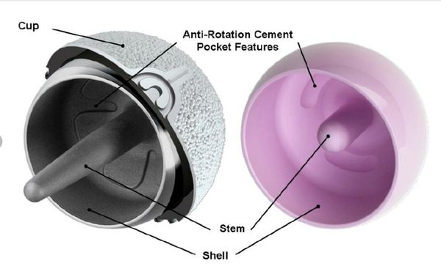
Femoral Component (Cap)
A smooth ceramic cap is placed over the reshaped femoral head. This covers the existing bone and creates a new low-friction surface for joint movement.
Acetabular Component (Socket)
A corresponding socket component is placed within the pelvis. This may include a ceramic bearing surface designed to allow smooth articulation with the femoral component.

Bearing Surfaces
The use of ceramic materials is a key feature of this procedure. Ceramic is chosen for its:
• Smooth surface characteristics
• Resistance to wear
• Biocompatibility
• Low friction movement

Unlike traditional metal-on-metal resurfacing, ceramic components are designed to avoid the production of metal wear particles, which has been a concern with earlier implant designs.

Implant Selection
The choice of implant is based on factors such as:
• Bone size and shape
• Joint anatomy
• Overall surgical plan

Careful selection and positioning of the implant components are important for supporting joint function and long-term performance.
Recovery, Physiotherapy and Rehabilitation After Hip Resurfacing Surgery
Recovery following hip resurfacing surgery is a structured process that focuses on restoring movement, rebuilding strength, and supporting a gradual return to daily activities. Because the procedure preserves the natural bone of the hip, rehabilitation is an important part of achieving a good functional outcome.

Early Recovery in Hospital
After surgery, you will be monitored in hospital as you begin the early stages of recovery. Most patients remain in hospital for approximately two to four days, depending on individual progress. Physiotherapy usually begins within the first day after surgery.

During this time, you will be guided through:
• Standing and walking with a frame or crutches
• Gentle exercises to activate the muscles around the hip
• Safe techniques for getting in and out of bed, chairs, and the bathroom
Early mobilisation helps improve circulation, reduce stiffness, and support the healing process.

Physiotherapy and Rehabilitation at Home
Once you return home, rehabilitation continues with a structured physiotherapy program. This focuses on gradually improving:
• Hip movement and flexibility
• Muscle strength around the hip and thigh
• Balance and walking pattern
• Overall mobility and confidence with daily activities
Some patients attend outpatient physiotherapy, while others begin with a home-based program before progressing to supervised rehabilitation.

Gradual Return to Activity
As your recovery progresses, walking distances and activity levels are gradually increased. Many patients are able to return to light daily activities within the first few weeks, with continued improvement over several months.
Higher levels of activity, including recreational exercise, are typically introduced in a progressive and controlled manner as strength and stability improve.

Recovery Timeframes
Recovery timelines vary between individuals and depend on factors such as age, fitness, bone quality, and pre-operative activity level. While early recovery occurs over the first few weeks, full recovery and return to higher levels of activity may take several months.
A consistent rehabilitation program and adherence to physiotherapy guidance are important in supporting a safe and steady recovery following hip resurfacing surgery.
Returning to Sport and Activity After Hip Resurfacing
Returning to activity is an important goal for many patients undergoing hip resurfacing surgery, particularly those who wish to maintain an active lifestyle. Because this procedure preserves more of the natural bone and joint mechanics, it may support a broader return to physical activity in appropriately selected patients.


Early Activity
In the early stages of recovery, the focus is on walking, gentle movement, and rebuilding strength. Low-impact activities such as walking are gradually increased as your mobility improves and physiotherapy progresses.

Progressing Activity Levels
As strength, balance, and joint control improve, activity levels can be increased in a structured and progressive way. Rehabilitation exercises are designed to support:
• Muscle strength around the hip
• Joint stability
• Coordination and movement control
These factors are important before returning to higher levels of activity.

Return to Sport
Many patients are able to return to a range of low- to moderate-impact activities, including:
• Walking and hiking
• Cycling
• Swimming
• Golf
In selected cases, a return to higher-impact activities or sport may be considered, depending on individual recovery, bone quality, and overall function. This is usually introduced gradually and with appropriate guidance.

Although hip resurfacing may be suitable for patients wishing to return to higher levels of activity, the progression back to sport is carefully structured and gradual. Activity levels are typically increased over a period of approximately six months, allowing time for the bone and surrounding tissues to adapt to the resurfaced joint. This gradual progression is important to help reduce the risk of complications, including stress fractures of the femoral neck, particularly in the early stages of recovery.

Individualised Guidance
The timing and type of activity you can return to will vary depending on your recovery progress and overall condition. A gradual and structured approach is important to allow the hip to adapt and strengthen over time. Guidance from your physiotherapist and follow-up assessments will help determine when it is appropriate to increase activity levels and return to specific sports.

Hip Resurfacing FAQ’s
What is the difference between hip resurfacing and total hip replacement?
Hip resurfacing preserves the femoral head by reshaping and capping it, whereas total hip replacement involves removing the femoral head and replacing it with a stem and ball component. Both procedures aim to relieve pain and improve movement but differ in technique and suitability.

Is ceramic hip resurfacing safer than metal-on-metal?
Ceramic hip resurfacing has been developed as an alternative to metal-on-metal bearings. Ceramic materials do not produce metal ions and are designed to have low wear characteristics, which may address some of the concerns associated with traditional metal-on-metal implants.

How long does hip resurfacing last?
Hip resurfacing implants are designed to be durable and long-lasting. Longevity can vary depending on factors such as activity level, bone quality, and implant positioning. Many patients experience many years of function, although long-term outcomes vary between individuals.

Am I too old or too young for hip resurfacing?
Hip resurfacing is generally considered for younger, active patients with good bone quality. It may be less suitable for patients with reduced bone density or more advanced joint damage. Suitability is assessed on an individual basis.

When can I walk after hip resurfacing surgery?
Most patients begin standing and walking within the first day after surgery with the assistance of a physiotherapist. Walking aids such as crutches or a frame are usually used initially.

When can I return to sport after hip resurfacing?
Many patients are able to return to low-impact activities such as walking, cycling, swimming, and golf as recovery progresses. In selected cases, a return to higher-impact activity may be considered following rehabilitation and medical guidance.

Will I have any movement restrictions after surgery?
In the early stages of recovery, you may be advised to follow certain movement precautions while the hip heals. These are usually temporary and are gradually reduced as strength and stability improve.

Will my leg lengths be the same after hip resurfacing?
Restoring leg length is an important part of surgical planning. Small differences can occasionally occur but often improve as muscles recover and the body adapts following surgery.

Can hip resurfacing be revised to a total hip replacement?
Yes. If required in the future, hip resurfacing can often be revised to a total hip replacement. Preserving bone during resurfacing may assist with future surgical options if needed.

How long will I stay in hospital after hip resurfacing?
Most patients remain in hospital for approximately two to four days, depending on recovery progress and overall health.

How painful is hip resurfacing surgery?
Pain levels vary between individuals, but modern pain management strategies are used to help keep you comfortable following surgery. Some post-operative discomfort is expected in the early stages of recovery.

When should I seek medical advice after surgery?
You should seek medical advice if you experience symptoms such as increasing pain, swelling, redness around the incision, fever, or difficulty moving the joint.

ENQUIRE NOW

